**A**

**Project Report**

**On**

**Lung Field Segmentation in Chest Radiographs from Boundary Maps by a Structured Edge Detector**

**ABSTRACT**

Lung field segmentation in chest radiographs (CXRs) is an essential preprocessing step in automatically analyzing such images. We present a method for lung field segmentation that is built on a high-quality boundary map detected by an efficient modern boundary detector, namely, a structured edge detector (SED). A SED is trained beforehand to detect lung boundaries in CXRs with manually outlined lung fields. Then, an ultrametric contour map (UCM) is transformed from the masked and marked boundary map. Finally, the contours with the highest confidence level in the UCM are extracted as lung contours. Our method is evaluated using the public JSRT database of scanned films. The average Jaccard index of our method is 95.2%, which is comparable with those of other state-of-the-art methods (95.4%). The computation time of our method is less than 0.1 s for a 256 × 256 CXR when executed on an ordinary laptop. Our method is also validated on CXRs acquired with different digital radiography units. The results demonstrate the generalization of the trained SED model and the usefulness of our method.

***Index Terms—***chest radiography, lung field segmentation, boundary detection, structured edge detector

**Chapter-1**

**INTRODUCTION**

Chest radiography (chest X-ray) is a diagnostic imaging technique widely used for lung diseases. The automatic segmentation of lung fields has received considerable attention from researchers as an essential preprocessing step in automatically analyzing chest radiographs (CXRs) [1-7]. An accurate automatic segmentation of lung fields can save physicians’ efforts for manual identification of the lung anatomy. In addition, this process is a necessary component of a computer-aided diagnosis system for detecting lung nodules [8]. The segmentation of lung fields is also useful for the anatomic region-based processing of CXRs, such as contrast enhancement of lung regions and bone suppression [10].

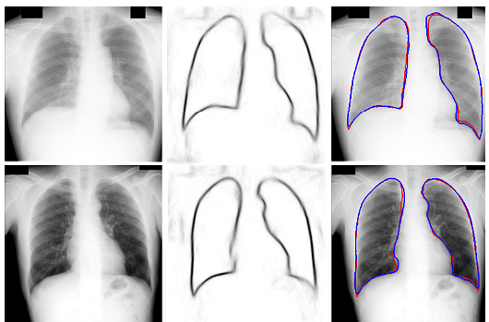

**Fig. 1. Examples of lung field segmentation by the proposed SEDUCM method. From left to right: CXRs, corresponding boundary maps produced by a trained SED, and segmentation results. Red and blue contours indicate the ground truth and automatic segmentation results, respectively.**

However, an accurate segmentation of lung fields in CXRs remains a challenge for several reasons. Lung fields exhibit large anatomical shape variations, including varying heart dimensions or other pathologies, across different patients in 2D radiographs. Lung fields in CXRs also contain several superimposed structures, such as lung vasculatures, clavicles, and ribs, which do not form the borders of lung fields. The strong edges at the rib and clavicle regions may result in inaccurate location of landmarks or inaccurate lung contours in some lung field segmentation approaches. In addition, segmenting the lung apex is difficult because of the varying intensities in the upper clavicle bone region.

Many lung field segmentation methods have been proposed for posterior–anterior (PA) CXRs to address these difficulties. These methods can be roughly divided into five categories: (1) rule-based methods, (2) pixel classification (PC)-based methods, (3) shape model-based methods, (4) hybrid methods, and (5) atlas-based methods. Rule-based segmentation methods [2, 3] contain sequences of steps and rules, such as thresholding or morphological operations. These methods have heuristic assumptions and compute approximate solutions below the global optimum. PC-based methods identify lung field segmentation as a classification problem and thus acquire a classifier to label each pixel as lung or background [4]. Most classification errors on the pixels around the boundaries of lung fields lead to inaccurate locations. Active shape models (ASM) and active appearance models (AAM) can incorporate low-level appearance cues and high-level shape priors, and have been successfully applied to lung field segmentation [4, 6]. In general, shape model-based methods tend to produce average shapes and are ineffective with abnormal cases. The segmentation performance of shape models relies on the approximation accuracy of the initial model. Hybrid methods produce improved results by fusing several techniques, but the segmentation algorithm is sophisticated and time consuming [4]. A recent study has introduced an atlas-based method that exhibits state-of-the-art performance; in this method, the CXR database of pre-segmented lung fields is used as the anatomical atlas, and the SIFT Flow algorithm is employed to align the CXR with the atlas [1]. In general, atlas-based methods are very time consuming. Lung segmentation can be refined through post-processing typically by using graph cuts [1, 12]. Among the energy functions for graph cuts, the boundary term is critical to improve segmentation accuracy. An accurate detection of lung boundaries is crucial to realize an accurate and simple automatic segmentation of lung fields.

However, lung boundaries are not always located on well-defined edges, where the gradient magnitude is maximum along the gradient direction. Simple gradients or derivatives of CXRs are insufficient for handling many anatomical structures and textures. Hence, an accurate detection of lung boundaries in CXRs is traditionally considered to be highly difficult. The classical Canny edge detector [13] and other edge detection methods based on image derivatives from CXRs can detect the edges not only along the borders of the lung but also along the borders of other anatomical structures such as the ribs and clavicles, which are almost not close contours. From the edges detected by the Canny edge detector, the candidate segments of lung boundaries are selected by the sophisticated rule-based reasoning method as in Ref. [3]. Tsujii et al. [14] developed a supervised lung boundary detector that uses 1D convolution neural networks trained to classify the pixels in CXRs into lung boundaries or otherwise. However, the detected lung boundaries in [14] are still not continuous and cannot be transformed directly to the lung segmentation.

Modern boundary detectors, such as Pb [15], structured edge detector (SED) [16], DeepEdge [17], and HED [18], are different from the classical Canny edge detector because these detectors emphasize the importance of suppressing false edge responses through an explicit oriented analysis of higher-order statistics. These statistics are obtained in various ways, including supervised learning. Such boundary detectors can benefit from global normalization provided by graph-spectral analysis or ultrametric consistency. These analyses enforce closure, thereby boosting the contrast of contours that completely enclose salient regions [19]. Most modern boundary detectors can be trained and provide a feasible way to detect the boundaries of particular objects. Among these modern boundary detectors, SED emerges as a distinguished system for edge detection because of its state-of-the-art performance and high speed [16].

In the present work, we aim to develop an accurate method for the real-time segmentation of lung fields in standard PA CXRs for practical applications. Unlike previous methods that use PC or shape models, we initially detect lung boundaries and then produce segmentation results from the detected boundary map. We select SED, which can be trained on samples of manually outlined lung fields, to detect lung boundaries efficiently. Lung contours are then extracted from an ultrametric contour map (UCM) [20], which is transformed from the boundary map detected by a trained SED and marker-controlled watershed transform (MWT) [21]. Our proposed method for lung field segmentation is called SEDUCM. In the SEDUCM segmentation pipeline, PC and initialization of shape models are not necessary. Fig. 1 shows two examples of the boundary maps detected by the trained SED and the segmentation results of lung fields through SEDUCM.

The remainder of this paper is organized as follows. The framework and details of our method are described in Section 2. Experimental results are provided in Section 3. The summary and discussion of results are shown in Section 4.

**IMAGE SEGMENTATION**

**Segmentation:**

In [computer vision](http://en.wikipedia.org/wiki/Computer_vision), segmentation refers to the process of partitioning a [digital image](http://en.wikipedia.org/wiki/Digital_image) into multiple [segments](http://en.wikipedia.org/wiki/Image_segment) ([sets](http://en.wikipedia.org/wiki/Set_%28mathematics%29) of [pixels](http://en.wikipedia.org/wiki/Pixel), also known as super pixels). The goal of segmentation is to simplify and/or change the representation of an image into something that is more meaningful and easier to analyze. Image segmentation is typically used to locate objects and boundaries (lines, curves, etc.) in images. More precisely, image segmentation is the process of assigning a label to every pixel in an image such that pixels with the same label share certain visual characteristics.

The result of image segmentation is a set of segments that collectively cover the entire image, or a set of [contours](http://en.wikipedia.org/wiki/Contour_line) extracted from the image (see [edge detection](http://en.wikipedia.org/wiki/Edge_detection)). Each of the pixels in a region is similar with respect to some characteristic or computed property, such as [color](http://en.wikipedia.org/wiki/Color), [intensity](http://en.wikipedia.org/wiki/Luminous_intensity), or [texture](http://en.wikipedia.org/wiki/Image_texture). [Adjacent](http://en.wikipedia.org/wiki/Adjacent) regions are significantly different with respect to the same characteristics.

* [Thresholding](http://www.qi.tnw.tudelft.nl/Courses/FIP/noframes/fip-Segmenta.html#Heading118)
* [Edge finding](http://www.qi.tnw.tudelft.nl/Courses/FIP/noframes/fip-Segmenta.html#Heading119)
* [Binary mathematical morphology](http://www.qi.tnw.tudelft.nl/Courses/FIP/noframes/fip-Segmenta.html#Heading120)
* [Gray-value mathematical morphology](http://www.qi.tnw.tudelft.nl/Courses/FIP/noframes/fip-Segmenta.html#Heading121)

mhtml:file://C:\Documents%20and%20Settings\user\Desktop\Image%20Processing%20Fundamentals%20-%20Segmentation.mht!http://www.qi.tnw.tudelft.nl/Courses/FIP/images/hr.gifIn the analysis of the objects in images it is essential that we can distinguish between the objects of interest and "the rest." This latter group is also referred to as the background. The techniques that are used to find the objects of interest are usually referred to as segmentation techniques - segmenting the foreground from background. In this section we will two of the most common techniques thresholding and edge finding and we will present techniques for improving the quality of the segmentation result. It is important to understand that:

1. There is no universally applicable segmentation technique that will work for all images, and,

2. No segmentation technique is perfect.

**What is segmentation?**

The first step in image analysis is to segment the image. Segmentation subdivides animage into its constituent parts or objects.

**Write the applications of segmentation**

The applications of segmentation are,i. Detection of isolated points.ii. Detection of lines and edges in an image.

**Chapter 2**

**DIGITAL IMAGE PROCESSING**

**Theory of Digital Image Processing**

An image is represented technically as two dimensional function f(x, y) which represents the intensity of selected pixel and here f denotes the intensity and x,y terms is termed as sparsity of pixel or weight of the pixel which gives the exact location of pixel in an digital image. Literally the digital image is also termed as “an image is not an image without any object in it”.

X-AXIS

YAXIS

f(x,y)

Figure 3.1 Digital image

**Representation of Digital image**

Generally a digital image is represented in pixels which are considered as minute elements of an image or also termed as pix. A pixel is a combination of 8 bits composed of both most significant bits and as well as least significant bits. Here an interesting point is that the most significant bits (MSB’s) have the resistive behaviour and least significant bits (LSB’s) have the acceptance behaviour. Whenever an image is prone to noise or any other variation in brightness, contrast, resolution then it will its impact mainly on least significant bits because of its acceptance behaviour. The respective bits are represented are looks as shown in the figure 3.2. These bits in a pixel are arranged in the cascading behaviour where all 8 bits intensity is shown in most significant bits of all pixels. Digital image image intensities are depends upon the arrangement of these bits in a proper way so as to visualize in a proper way to human visual system (HVS).

BIT 1

BIT 2

BIT 3

BIT 4

BIT 5

BIT 6

BIT 7

BIT 8

MSB’s

LSB’s

**Figure 3.2 Cascading approach of bits in an pixel**

In the figure 3.2, the cascading approach of bits with respect to most significant bits and least significant bits are shown and how all the respective 8 bits intensity is combined to form the final intensity value in the final most significant bit and how the final intensity falls on human visual system to make the feel of object in an digital image and technically it is termed as human perception of digital image. These bits are logically present while the least element visualized by the human visual system is the pixel and in order to form the pixel we need to compose all the 8 respective bits value to visualize the digitalized content in an pleasant approach. These bits plays a crucial role in security related applications such as watermarking, steganography etc.

**What is the need for processing an digital image?**

Digital image processing plays an prominent role many application oriented fields as military, biometric, robotics, genetics, radar image processing, satellite image processing and medical image processing and so on. When ever an image tends to change its behaviour from the normal form to abnormal form then it indicates that the variation in the brightness, variation in the contrast levels, variation in the resolution etc and in another scenario it may tends to change the behaviour due to environmental disturbances termed as Gaussian noise and man made mistakes such as applying the inaccurate algorithm, hand jitter and mainly medical field is an application where the processing plays a vital role to understand the patient condition by the respective physician but this happen after we have the statistics in a proper way if processing is not done then so many medical related applications are fails.

Digital image processing

MEDICINE

MILITARY

RADAR

SATELLITE

INDUSTRY

ACADEMIA

SECURITY

BIOMETRICS

**Figure 3.3 Digital image processing applications**

**Steps in Digital image processing**

***Image Acquisition***

Acquiring the digital image is done by using the sensors, radars, satellites, cameras and so on***.*** Although acquisition looks as a simple approach when come to logical way it is a challenging task. Mainly it consists of two important steps compression of image and enhancement of image. Whenever we are acquiring an object by using any digital sensory device it first compress the particular object by 0 percent then iut enhance the respective object according to the resolution of the device for better view of the image by the human visual system.

Digital image sensory device

**Figure 3.4 Digital image Acquisition process**

***Image Enhancement***

Image processing has related problems like inpainting problem. Generally due to the continuous variation in the lighting conditions and variations in the other factors we acquire the low quality photographs. Due to the changes in the real time lighting conditions instead of high quality photographs we acquire the low quality photographs, further to enhance the quality of low quality images we have to improve the several parameters and factors which are related to the digital image in order to yield the high end high quality images in place of low quality images.

The factors related to digital image to improve the quality are contrast, brightness levels, decreasing the noise impact on image etc. Naturally a question arises why we have to convert the low quality digital image to the high quality digital image or why we have to enhance the quality of digital image. In order to enhance the low quality digital we need opts for the better enhancement techniques which are already exist. In the category of enhancement techniques most successful and highly used enhancement technique is contrast enhancement technique.

The most important thing taken into consideration while enhancing the low quality digital images is the necessary technique must adaptive to the respective relative displays especially the contrast enhancement technique. In literature so many frameworks and algorithms are proposed but most of the algorithms are based on the enhancement. Lot of research has been to improve the digital quality based on not only enhancement techniques but also merely on the power saving also simultaneously.

***Image Compression***

Digital image Compression plays an prominent role in many image processing applications. But compression an image depends upon many crucial factors such as image strength that is mainly depends upon the brightness, contrast levels so on. Especially in applications like steganography and watermarking where the data is embedded or hidden on the image. After successfully embedding the data before transmission the respective image need to compress for security concerns.

The compression of digital image may tends to loose the information if properly not compressed and in some cases due to weak encoding algorithm approach the retrieval process became more difficult to retrieve the data then it tends to loose the important information. Compression techniques has some popular approaches like DCT compression technique, JPEG compression etc.

**Figure 3.5 Compression of digital image**

Digital image can be represented in two different ways, in first approach where one can view the content of image like object but we cannot see the pixels and its values and it is called the digital image. In second approach we can view the pixels and its statistics but we cannot view the content like object in it and it is called as the histogram. Histogram technical calls as the graphical representation of the minute pixels values of the image that is pixels. The main advantage of the digital image histogram is that by viewing the statistics of histogram one can get clear estimation of the tonal estimation of the respective digital image.

Digital image histogram plays an important role in many image processing applications and to analyze the digital image tonal estimation. This histogram representation of the respective image mostly helpful to photographers to built the photographs according to the requirement5 by adjusting the tonal corrections by using the statistics of image histogram. By removing the show like contents from the image and enhance the tonal corrections at the shadow like scenario we can get clear view of the image to the human visual system. Digital image histogram has two sections namely the horizontal section and the vertical section. The horizontal section representation the histogram called as horizontal axis which represents the variations in the tonal corrections and on the end at the vertical view we get statistics related to the tonal correction variations which are at the vertical axis.

Initially it is reported that the Internal Generative Mechanism approach is applied on the brain related issues i.e. in order to view visual sensual processing of the brain we first applied on the brain and it is termed as Internal generative mechanism of the brain.

The main advantage of the internal generative mechanism is to analyze the different types of distortions and its impact to degrade the image or signal from normal to abnormal behaviour. The basic and most used approach from early days of human existence is the Human Visual System mechanism to understand the image behaviour and to view the distortion related changes in digital image. To understand the effective image perception and to recognize the respective object in a digital image is done efficiently by human visual system. The accurate system to view the outside world and to perceive its internal behaviour the basic system which we follow from stating of human existence is human eyes which are quite effective and efficient to distinguish between the noise free image and noise effected image.

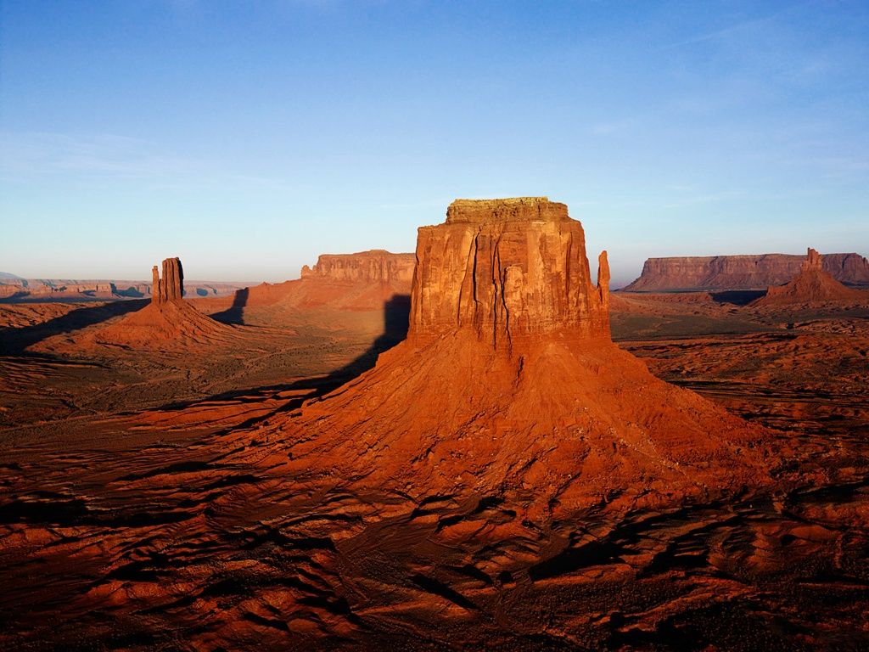

**Figure 3.5 Digital image**

In Histogram Equalization (HE) technique in order to equalize the all the background pixel intensities we make use of the normalization approach. But while assessing the power consumption using the Histogram Equalization (HE) technique is mainly affected by the pixel intensities rather than background light intensities. So an enhanced power consumption model is implemented based on the Histogram Equalization (HE) term and index term

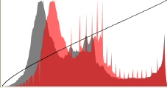

**Figure 3.6 Histogram of Respective digital image**

**Histogram Equalization**

Histogram has many different types like histogram rotation, histogram distribution, histogram shifting, and histogram equalization. Histogram equalization plays vital role in many digital processing applications and moreover when the important in an digital image is at the close contrast values by using histogram equalization technique we can increase the levels of global contrast of many different images which has the important information at the close contrast values. By using the histogram equalization intensities of pixels related to digital image can be distributed in better way to visualize better by human visual system. The main advantage of the digital image histogram equalization is that it equalizes the all values of pixels so that the pixels with low intensities can get the better visual appearance this is done by spreading the higher values to the low pixel values by using the histogram equalization approach.

The main usage of histogram equalization is done on images especially with the images which has the both the brighter range of pixels and as well as the darker range of pixels. Histogram equalization technique has wider range of applications as mentioned below

1. Radar related applications
2. Defence and military related applications
3. Medicine related applications
4. Digital image processing applications
5. Security related applications

In medicine related applications histogram equalization yields the better results compares to the other techniques. In order to visualize the content in x ray images usage of the histogram equalization approach is so critical. The main advantages of the histogram equalization approach are that its operation is fairly moreover straight forward and also acts as an invertible operator. In theoretical approach we have histogram equalization function as enhancement related function which recovers the data of the original histogram. The main disadvantage of this method is it takes long time to yield the desired result means run time complexity and simultaneously sharp rise in the back ground noise also the area of concern.

In some applications spatial correlation plays a vital role in especially in scientific imaging applications also in the genetic image processing applications but due to the over sensitivity of these applications signal to noise ratio is in adverse situation when using the histogram equalization approach.

**Chapter 3**

**LITERATURE SURVEY**

**S. Candemir, S. Jaeger, K. Palaniappan, J. P. Musco, R. K. Singh, X. Zhiyun, A. Karargyris, S. Antani, G. Thoma, and C. J. McDonald,**

The National Library of Medicine (NLM) is developing a digital chest X-ray (CXR) screening system for deployment in resource constrained communities and developing countries worldwide with a focus on early detection of tuberculosis. A critical component in the computer-aided diagnosis of digital CXRs is the automatic detection of the lung regions. In this paper, we present a nonrigid registration-driven robust lung segmentation method using image retrieval-based patient specific adaptive lung models that detects lung boundaries, surpassing state-of-the-art performance. The method consists of three main stages: 1) a content-based image retrieval approach for identifying training images (with masks) most similar to the patient CXR using a partial Radon transform and Bhattacharyya shape similarity measure, 2) creating the initial patient-specific anatomical model of lung shape using SIFT-flow for deformable registration of training masks to the patient CXR, and 3) extracting refined lung boundaries using a graph cuts optimization approach with a customized energy function. Our average accuracy of 95.4% on the public JSRT database is the highest among published results. A similar degree of accuracy of 94.1% and 91.7% on two new CXR datasets from Montgomery County, MD, USA, and India, respectively, demonstrates the robustness of our lung segmentation approach.

**B. v. Ginneken, and B. M. t. H. Romeny,**

The delineation of important structures in chest radiographs is an essential preprocessing step in order to automatically analyze these images, e.g., for tuberculosis screening support or in computer assisted diagnosis. We present algorithms for the automatic segmentation of lung fields in chest radiographs. We compare several segmentation techniques: a matching approach; pixel classifiers based on several combinations of features; a new rule-based scheme that detects lung contours using a general framework for the detection of oriented edges and ridges in images; and a hybrid scheme. Each approach is discussed and the performance of nine systems is compared with inter observer variability and results available from the literature. The best performance is obtained by the hybrid scheme that combines the rule-based segmentation algorithm with a pixel classification approach. The combinations of two complementary techniques lead to robust performance; the accuracy is above 94% for all 115 images in the test set. The average accuracy of the scheme is 0.969 +/- 0.0080, which is close to the inter observer variability of 0.984 +/- 0.0048. The methods are fast, and implemented on a standard PC platform.

**M. S. Brown, L. S. Wilson, B. D. Doust, R. W. Gill, and C. Sun**

We present a knowledge-based approach to segmentation and analysis of the lung boundaries in chest X-rays. Image edges are matched to an anatomical model of the lung boundary using parametric features. A modular system architecture was developed which incorporates the model, image processing routines, an inference engine and a blackboard. Edges associated with the lung boundary are automatically identified and abnormal features are reported. In preliminary testing on 14 images for a set of 18 detectable abnormalities, the system showed a sensitivity of 88% and a specificity of 95% when compared with assessment by an experienced radiologist. q 1999 Elsevier Science Ltd. All rights reserved.

We have developed a knowledge-based approach to lung boundary interpretation in chest X-rays. Within a modular system architecture, an explicit anatomical model is matched to image data by mapping both to a common feature space for comparison. The knowledge-based approach augments low-level segmentation techniques by allowing high-level image interpretation. In our approach, domain knowledge provides guidance for object recognition. Using the hierarchy implied by relationships in the model, the internecine and control system automatically schedules the identification of anatomical structures. Both a priori and a posteriori information are combined to constrain segmentation of expected anatomy. We have developed methods for modeling normal and pathological variations in anatomy. Fuzzy sets provide an intuitive representation and allow symbolic description of image feature values, so that high-level rules can be used to generate reports on suspected abnormalities. Preliminary experimental results are encouraging but further validation is required.

**B. v. Ginneken, M. B. Stegmann, and M. Loog,**

In this paper we present a solution for segmenting anatomical structures on chest radiographs. First we show an algorithm for the lung contour detection, then we describe a method for finding the ribs and clavicles. The results of these procedures are used as input for a bone shadow elimination algorithm. Different implementation results are also discussed, like C++ and a parallel solution on GPU.

It was shown that the lung contour detection can be solved with decent accuracy while keeping runtime low enough with the use of GPU for real-time evaluation. The results were good enough to be used for further processing steps. The presented clavicle outline detection algorithm performed well on digital radiographs, but further enhancement is still possible to handle the fainter contours of the JSRT images. The rib detection algorithm found enough ribs to produce a clean image of the lung after eliminating the shadows, but in some irregular cases it still skips too many ribs, however there are a lot of possible ways to enhance it.

**D. Seghers, D. Loeckx, F. Maes, D. Vandermeulen, and P. Suetens,**

A new generic model-based segmentation algorithm is presented, which can be trained from examples akin to the active shape model (ASM) approach in order to acquire knowledge about the shape to be segmented and about the gray-level appearance of the object in the image. Whereas ASM alternates between shape and intensity information during search, the proposed approach optimizes for shape and intensity characteristics simultaneously. Local gray-level appearance information at the landmark points extracted from feature images is used to automatically detect a number of plausible candidate locations for each landmark. The shape information is described by multiple landmark-specific statistical models that capture local dependencies between adjacent landmarks on the shape. The shape and intensity models are combined in a single cost function that is optimized non iteratively using dynamic programming, without the need for initialization. The algorithm was validated for segmentation of anatomical structures in chest and hand radiographs. In each experiment, the presented method had a significant higher performance when compared to the ASM schemes. As the method is highly effective, optimally suited for pathological cases and easy to implement, it is highly useful for many medical image segmentation tasks.

**Y. Shao, Y. Gao, Y. Guo, Y. Shi, X. Yang, and D. Shen,**

Lung field segmentation in the posterior-anterior (PA) chest radiograph is important for pulmonary disease diagnosis and hemo dialysis treatment. Due to high shape variation and boundary ambiguity, accurate lung field segmentation from chest radiograph is still a challenging task. To tackle these challenges, we propose a joint shape and appearance sparse learning method for robust and accurate lung field segmentation. The main contributions of this paper are: 1) a robust shape initialization method is designed to achieve an initial shape that is close to the lung boundary under segmentation; 2) a set of local sparse shape composition models are built based on local lung shape segments to overcome the high shape variations; 3) a set of local appearance models are similarly adopted by using sparse representation to capture the appearance characteristics in local lung boundary segments, thus effectively dealing with the lung boundary ambiguity; 4) a hierarchical deformable segmentation framework is proposed to integrate the scale-dependent shape and appearance information together for robust and accurate segmentation. Our method is evaluated on 247 PA chest radiographs in a public dataset. The experimental results show that the proposed local shape and appearance models outperform the conventional shape and appearance models. Compared with most of the state-of-the-art lung field segmentation methods under comparison, our method also shows a higher accuracy, which is comparable to the inter-observer annotation variation.

**T. Xu, M. Mandal, R. Long, I. Cheng, and A. Basu,**

Automatic and accurate lung field segmentation is an essential step for developing an automated computer-aided diagnosis system for chest radiographs. Although active shape model (ASM) has been useful in many medical imaging applications, lung field segmentation remains a challenge due to the superimposed anatomical structures. We propose an automatic lung field segmentation technique to address the inadequacy of ASM in lung field extraction. Experimental results using both normal and abnormal chest radiographs show that the proposed technique provides better performance and can achieve 3-6% improvement on accuracy, sensitivity and specificity compared to traditional ASM techniques.

**A.M. R. Schilham, B. van Ginneken, and M. Loog,**

A computer algorithm for nodule detection in chest radiographs is presented. The algorithm consists of four main steps: (i) image preprocessing; (ii) nodule candidate detection; (iii) feature extraction; (iv) candidate classification. Two optional extensions to this scheme are tested: candidate selection and candidate segmentation. The output of step (ii) is a list of circles, which can be transformed into more detailed contours by the extra candidate segmentation step. In addition, the candidate selection step (which is a classification step using a small number of features) can be used to reduce the list of nodule candidates before step (iii). The algorithm uses multi-scale techniques in several stages of the scheme: Candidates are found by looking for local intensity maxima in Gaussian scale space; nodule boundaries are detected by tracing edge points found at large scales down to pixel scale; some of the features used for classification are taken from a multi-scale Gaussian filter bank. Experiments with this scheme (with and without the segmentation and selection steps) are carried out on a previously characterized, publicly available data base, that contains a large number of very subtle nodules. For this database, counting as detections only those nodules that were indicated with a confidence level of 50% or more, radiologists previously detected 70% of the nodules. For our algorithm, it turns out that the selection step does have an added value for the system, while segmentation does not lead to a clear improvement. With the scheme with the best performance, accepting on average two false positives per image results in the identification of 51% of all nodules. For four false positives, this increases to 67%. This is close to the previously reported 70% detection rate of the radiologists.

**B. van Ginneken, M. B. Stegmann, and M. Loog,**

The task of segmenting the lung fields, the heart, and the clavicles in standard posterior-anterior chest radiographs is considered. Three supervised segmentation methods are compared: active shape models, active appearance models and a multi-resolution pixel classification method that employs a multi-scale filter bank of Gaussian derivatives and a k-nearest-neighbors classifier. The methods have been tested on a publicly available database of 247 chest radiographs, in which all objects have been manually segmented by two human observers. A parameter optimization for active shape models is presented, and it is shown that this optimization improves performance significantly. It is demonstrated that the standard active appearance model scheme performs poorly, but large improvements can be obtained by including areas outside the objects into the model. For lung field segmentation, all methods perform well, with pixel classification giving the best results: a paired t-test showed no significant performance difference between pixel classification and an independent human observer. For heart segmentation, all methods perform comparably, but significantly worse than a human observer. Clavicle segmentation is a hard problem for all methods; best results are obtained with active shape models, but human performance is substantially better. In addition, several hybrid systems are investigated. For heart segmentation, where the separate systems perform comparably, significantly better performance can be obtained by combining the results with majority voting. As an application, the cardio-thoracic ratio is computed automatically from the segmentation results. Bland and Altman plots indicate that all methods perform well when compared to the gold standard, with confidence intervals from pixel classification and active appearance modeling very close to those of a human observer. All results, including the manual segmentations, have been made publicly available to facilitate future comparative studies.

**S. Chen, and K. Suzuki**

Most lung nodules that are missed by radiologists as well as computer-aided detection (CADe) schemes overlap with ribs or clavicles in chest radiographs (CXRs). The purpose of this study was to separate bony structures such as ribs and clavicles from soft tissue in CXRs. To achieve this, we developed anatomically specific multiple massive-training artificial neural networks (MTANNs) combined with total variation (TV) minimization smoothing and a histogram-matching-based consistency improvement method. The anatomically specific multiple MTANNs were designed to separate bones from soft tissue in different anatomic segments of the lungs. Each of the MTANNs was trained with the corresponding anatomic segment in the teaching bone images. The output segmental images from the multiple MTANNs were merged to produce an entire bone image. TV minimization smoothing was applied to the bone image for reduction of noise while preserving edges. This bone image was then subtracted from the original CXR to produce a soft-tissue image where bones were separated out. This new method was compared with conventional MTANNs with a database of 110 CXRs with nodules. Our new anatomically specific MTANNs separated rib edges, ribs close to the lung wall, and the clavicles from soft tissue in CXRs to a substantially higher level than did the conventional MTANNs, while the conspicuity of lung nodules and vessels was maintained. Thus, our technique for bone–soft-tissue separation by means of our new MTANNs would be potentially useful for radiologists as well as CADe schemes in detection of lung nodules on CXRs.

We have developed an anatomically specific multiple MTANN scheme to suppress bony structures in CXRs. With our new technique, rib edges, ribs close to the lung wall, and the clavicles were suppressed substantially better than was possible with our conventional technique, while soft tissue such as lung nodules and vessels was maintained. Thus, our technique would be useful for radiologists as well as for CADe schemes in the detection of lung nodules in CXRs.

**B. Ibragimov, B. Likar, F. Pernus, and T. Vrtovec,**

A novel game-theoretic framework for landmark-based image segmentation is presented. Landmark detection is formulated as a game, in which landmarks are players, landmark candidate points are strategies, and likelihoods that candidate points represent landmarks are payoffs, determined according to the similarity of image intensities and spatial relationships between the candidate points in the target image and their corresponding landmarks in images from the training set. The solution of the formulated game-theoretic problem is the equilibrium of candidate points that represent landmarks in the target image and is obtained by a novel iterative scheme that solves the segmentation problem in polynomial time. The object boundaries are finally extracted by applying dynamic programming to the optimal path searching problem between the obtained adjacent landmarks. The performance of the proposed framework was evaluated for segmentation of lung fields from chest radiographs and heart ventricles from cardiac magnetic resonance cross sections. The comparison to other landmark-based segmentation techniques shows that the results obtained by the proposed game-theoretic framework are highly accurate and precise in terms of mean boundary distance and area overlap. Moreover, the framework overcomes several shortcomings of the existing techniques, such as sensitivity to initialization and convergence to local optima.

**Y. Boykov, O. Veksler, and R. Zabih,**

In this paper we address the problem of minimizing a large class of energy functions that occur in early vision. The major restriction is that the energy function’s smoothness term must only involve pairs of pixels. We propose two algorithms that use graph cuts to compute a local minimum even when very large moves are allowed. The first move we consider is an α-βswap: for a pair of labels α, β, this move exchanges the labels between an arbitrary set of pixels labeled α and another arbitrary set labeled β. Our first algorithm generates a labeling such that there is no swap move that decreases the energy. The second move we consider is an α-expansion: for a label α, this move assigns an arbitrary set of pixels the label α. Our second algorithm, which requires the smoothness term to be a metric, generates a labeling such that there is no expansion move that decreases the energy. Moreover, this solution is within a known factor of the global minimum. We experimentally demonstrate the effectiveness of our approach on image restoration, stereo and motion.

**J. Canny,**

This paper describes a computational approach to edge detection. The success of the approach depends on the definition of a comprehensive set of goals for the computation of edge points. These goals must be precise enough to delimit the desired behavior of the detector while making minimal assumptions about the form of the solution. We define detection and localization criteria for a class of edges, and present mathematical forms for these criteria as functionals on the operator impulse response. A third criterion is then added to ensure that the detector has only one response to a single edge. We use the criteria in numerical optimization to derive detectors for several common image features, including step edges. On specializing the analysis to step edges, we find that there is a natural uncertainty principle between detection and localization performance, which are the two main goals. With this principle we derive a single operator shape which is optimal at any scale. The optimal detector has a simple approximate implementation in which edges are marked at maxima in gradient magnitude of a Gaussian-smoothed image. We extend this simple detector using operators of several widths to cope with different signal-to-noise ratios in the image. We present a general method, called feature synthesis, for the fine-to-coarse integration of information from operators at different scales. Finally we show that step edge detector performance improves considerably as the operator point spread function is extended along the edge.

**O. Tsujii, M. T. Freedman, and S. K. Mun,**

The purposes of this research are to investigate the effectiveness of our novel lung contour detection method in chest radiographs. The proposed method consists of five sections as follows. First, in order to reduce the amount of information, the images are smoothed and sub sampled from 2 k by 2.5 k pixels to 256 by 310 pixels with rescaling from 12-bit to 8-bit based on the image maximum and minimum. Second,that the image is resolved into the profiles for two directions (i.e., horizontal x and vertical y axes). Then, for each direction, those profiles are tested by the neural network which has been trained using the profiles from 14 pairs of original and target images. Note that both horizontal and vertical neural networks are trained with the horizontal and vertical profiles, respectively. For each direction, the whole two-dimensional image is reconstructed from the output profiles of the neural network. Next, the binarization process followed by the labeling process is applied to each reconstructed image individually. Finally, two post processed images are combined through the OR operation, and the labeling process is performed for the combined image to get the final contour. A total of 85 screening chest radiographs from Johns Hopkins University Hospital were digitized to 2 k by 2.5 k pixels with 12-bit gray scale. Fourteen images were used for the training of the neural networks and the remaining 71 images for testing. The proposed method can detect the lung contour at 94% accuracy for test images following the same rules as for the training images.

**D. R. Martin, C. C. Fowlkes, and J. Malik,**

The goal of this work is to accurately detect and localize boundaries in natural scenes using local image measurements. We formulate features that respond to characteristic changes in brightness, color, and texture associated with natural boundaries. In order to combine the information from these features in an optimal way, we train a classifier using human labeled images as ground truth. The output of this classifier provides the posterior probability of a boundary at each image location and orientation. We present precision-recall curves showing that the resulting detector significantly outperforms existing approaches. Our two main results are 1) that cue combination can be performed adequately with a simple linear model and 2) that a proper, explicit treatment of texture is required to detect boundaries in natural images.

We have defined a novel set of brightness, color, and texture cues appropriate for constructing a local boundary model, as well as a methodology for benchmarking boundary detection algorithms. By using a large data set of human-labeled boundaries in natural images, we have formulated the task of cue combination for local boundary detection as a supervised learning problem. This approach models the true posterior probability of a boundary at every image location and orientation, which is particularly useful for higher-level algorithms. The choice of classifier for modeling the posterior probability of a boundary based on local cues is not important—a simple linear model is sufficiently powerful. Based on a quantitative evaluation on 100 natural images, our detector outperforms existing methods, indicating that a proper treatment of texture is essential for detecting boundaries in natural images.

**P. Dollár, and C. L. Zitnick**

Edge detection is a critical component of many vision systems, including object detectors and image segmentation algorithms. Patches of edges exhibit well-known forms of local structure, such as straight lines or T-junctions. In this paper we take advantage of the structure present in local image patches to learn both an accurate and computationally efficient edge detector. We formulate the problem of predicting local edge masks in a structured learning framework applied to random decision forests. Our novel approach to learning decision trees robustly maps the structured labels to a discrete space on which standard information gain measures may be evaluated. The result is an approach that obtains realtime performance that is orders of magnitude faster than many competing state-of-the-art approaches, while also achieving state-of-the-art edge detection results on the BSDS500 Segmentation dataset and NYU Depth dataset. Finally, we show the potential of our approach as a general purpose edge detector by showing our learned edge models generalize well across datasets.

In conclusion, we propose a structured learning approach to edge detection. We describe a general purpose method for learning structured random decision forest that robustly uses structured labels to select splits in the trees. We demonstrate state-of-the-art accuracies on two edge detection datasets, while being orders of magnitude faster than most competing state-of-the-art methods

**G. Bertasius, S. Jianbo, and L. Teresina,**

Contour detection has been a fundamental component in many image segmentation and object detection systems. Most previous work utilizes low-level features such as texture or saliency to detect contours and then use them as cues for a higher-level task such as object detection. However, we claim that recognizing objects and predicting contours are two mutually related tasks. Contrary to traditional approaches, we show that we can invert the commonly established pipeline: instead of detecting contours with low-level cues for a higher-level recognition task, we exploit object-related features as high-level cues for contour detection. We achieve this goal by means of a multi-scale deep network that consists of five convolutional layers and a bifurcated fully-connected sub-network. The section from the input layer to the fifth convolutional layer is fixed and directly lifted from a pre-trained network optimized over a large-scale object classification task. This section of the network is applied to four different scales of the image input. These four parallel and identical streams are then attached to a bifurcated sub-network consisting of two independently-trained branches. One branch learns to predict the contour likelihood (with a classification objective) whereas the other branch is trained to learn the fraction of human labelers agreeing about the contour presence at a given point (with a regression criterion). We show that without any feature engineering our multi-scale deep learning approach achieves state-of-the-art results in contour detection.

**S. Xie, and Z. Tu,**

We develop a new edge detection algorithm that tackles two important issues in this long-standing vision problem: (1) holistic image training and prediction; and (2) multi-scale and multi-level feature learning. Our proposed method, holistically-nested edge detection (HED), performs image-to-image prediction by means of a deep learning model that leverages fully convolutional neural networks and deeply-supervised nets. HED automatically learns rich hierarchical representations (guided by deep supervision on side responses) that are important in order to approach the human ability resolve the challenging ambiguity in edge and object boundary detection. We significantly advance the state-of-the-art on the BSD500 dataset (ODS F-score of .782) and the NYU Depth dataset (ODS F-score of .746), and do so with an improved speed (0.4 second per image) that is orders of magnitude faster than some recent CNN-based edge detection algorithms.

**Chapter-4**

**PROPOSED METHODS**

**Fig. 2. Flowchart of our proposed method for lung field segmentation.**

1. **Overview**

This work aims to develop a practical and useful method for automatically segmenting lung fields in CXRs. The core of our proposed method is the effective use of the lung boundary map produced by SED. As shown in Fig. 2, an input CXR was first normalized into the intensity range [0, 1] and decomposed as the input of SED to the base and detail layers by a guided filter [22]. Next, a boundary map was produced by the SED model trained for detecting the boundaries of lung fields. From the boundary map and the input CXR, the ribcage and spinal centerline were extracted. These segments were used to partition the CXR into the right and left thorax areas as well as clean the boundary map for further processing. Subsequently, the candidate lung regions and contours were generated by using MWT and UCM transforms (mwt-ucm). Finally, the contours with the highest confidence level were selected as the right and left lung contours. To effectively perform segmentation, each step of the proposed method employed highly efficient algorithms for executing the corresponding functions, including guided filter [22], dynamic programming, and watershed transform (WT).

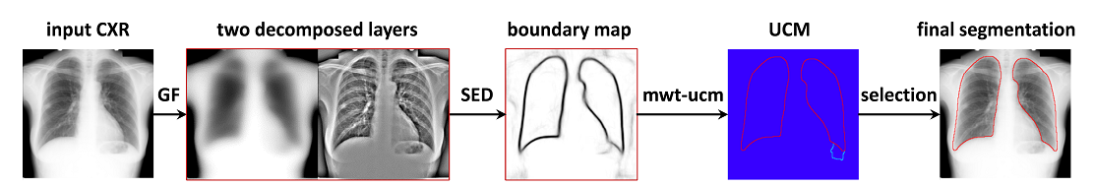

**Fig. 3. Intermediate results of an input CXR in SEDUCM pipeline.**

1. **SED for Detecting Lung Boundaries**

We first reviewed the SED proposed by Dollár and Zitnic [16]. Dollár and Zitnic formulated the edge detection task in a general structured learning framework where a random decision forest [23, 24] is exploited to general structured output spaces. SED has the advantage of the inherent structure in edge patches and can be computed efficiently.

A decision tree ft (x) classifies an input x∈ by splitting the data between the left and right sub-trees according to a binary split function h(x, θj) with parameter θj at each node j. Given a node j and a training set S⊂×, the training goal of the decision tree is to find parameter θj that maximizes the information gain criterion Ij defined by



At each internal node of the tree, a feature is chosen to split the incoming training samples to maximize some criteria. A random decision forest comprises multiple independent decision trees [23, 24]. Given a sample, the predictions from the set of decision trees are combined into a single output by using an ensemble model.

Dollár et al. [16] extended random forests to structured random forests for predicting structured outputs. Given an image patch x∈, the output y∈ stores the corresponding segmentation mask or binary edge map. A segmentation mask is denoted by y∈ = d×d and a binary edge map is represented by y'∈' = {0, 1}d×d, where d is the patch width. The main goal of structured random forests is to map all structured labels to a discrete set c∈. Dollár et al. solved this problem by first mapping the structured output space  to an intermediate space . z = Π(y) is defined as a long binary vector that encodes whether each pair of pixels in y belongs to the same or different segments. The problem with the high dimensionality of the structured output space  is alleviated by sampling a few dimensions of  followed by conducting principal component analysis (PCA). Then, the intermediate space  is mapped to the discrete label space  by PCA quantization. Thus, the standard information gain criteria based on Gini impurity can be adopted to train structured random forests. In a trained structured random forest, the learned edge masks y' are averaged as a soft edge response and stored at each left node. Although SED is originally designed to detect general edges on natural images, it can be adopted to detect the boundaries of particular objects, such as lung boundaries in CXRs.

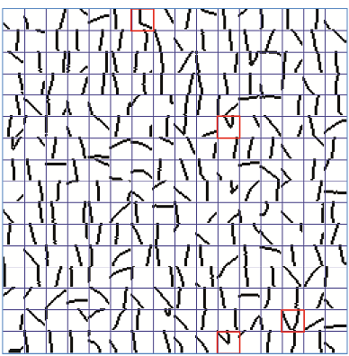

**Fig. 4. Examples of boundary patches in the leaf nodes of the trained SED. The red rectangles indicate some representative boundary fragments which locate along the lower lobes of lung.**

We began by decomposing an input CXR into its base and detail layers using a guided filter as shown in Fig. 3. The guided filter performs edge-preserving smoothing on an image like the bilateral filter, using the content of a guidance image, to influence the filtering. One advantage of the guided filter is that it can be implemented efficiently through integral image technique. We used the input CXR itself as the guidance image, and the kernel radius and the regularization coefficient of the guided filter were set to 8 and 0.1, respectively. The base layer is for extracting coarse-scale features of the input CXR, whereas the detail layer is for extracting fine-scale features. These two layers were normalized to zero mean and one variance as the input feature maps of SED. The feature extraction and the SED training approach presented in Ref. [16] were adopted in this work. The SED predicted the centered 16 × 16 lung boundary response from a 32 × 32 × 2 image patch. Each image patch was augmented to obtain 12 channels, including 2 input channels, 2 gradient magnitude channels, and 8 gradient orientation channels. A total of 6,672 candidate features were efficiently extracted from a 32 × 32 × 12 patch, similar to that in Ref. [16].

Fig. 4 shows 256 randomly selected patches of the lung boundary response in the leaf nodes of a learned structured random forest. Each patch of the boundary response exhibits the shape characteristics of particular locations along the lung boundaries. Compared with a global shape model, the patches of the boundary response can be viewed as local shape fragments and are more flexible to composite the lung contours.

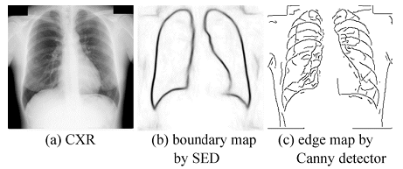

**Fig. 5. Example of boundary map produced with the trained SED and edge map detected by the Canny edge detector.**

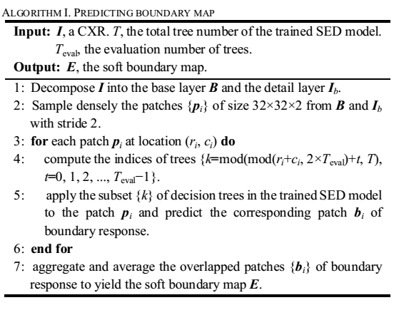

During the prediction stage, the image patches are sampled densely from the base and detail layers of an input CXR, and SED predicts their corresponding patches of boundary response. Then, the overlapped patches of boundary response were averaged and aggregated to yield a map of soft boundary response. The efficiency of SED can be further improved by reducing the number of densely sampled image patches and the number of decision trees evaluated during the prediction stage since both the inputs and outputs of each decision tree overlap. Similar to the settings in [16], the stride of image patch sampling was set to 2 pixels and an alternating subset of decision trees was evaluated on the sampled image patches at each adjacent location. The procedure of predicting boundary map for a CXR is described in Algorithm I.

Dollár et al. [16] proposed a sharpening procedure on the boundary map using local color or intensity cues. However, sharpening the boundary map would lead to less smooth lung contours and degrade the segmentation performance. Therefore, the lung boundary maps predicted by SED were not sharpened but rather slightly smoothed using a triangle filter with a kernel size of 1 pixel in our work. Examples of boundary maps detected by the trained SED are shown in Figs. 1 and 5. An edge map detected by the Canny edge detector for a CXR is shown in Fig. 5(c). The borders of the ribs and body were identified as the edges by the Canny edge detector. The trained SED can effectively distinguish the lung boundaries from the other structures. The response values along the lung contours are significantly larger than other regions in the boundary map produced by SED.

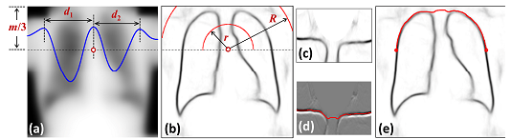

**Fig. 6. Determination of the ribcage top. In (a), the blue line presents the horizontal intensity profile at 1/3 of image height of the base layer of a CXR, and the small red circle indicates the center point for polar transformation. The two dashed red semicircles in (b) delimit the sampling range of polar transform. (c) Polar transform result from (b). The optimal path overlaid on the energy function is displayed in (d). The red line is the detected boundary ofThe red line is the detected boundary of lung top in Cartesian coordinates in (e).**

1. **Finding Thorax Centerline and Ribcage for Partition**

Although high-quality lung boundary maps can be produced using the trained SED, false responses for lung boundary still exist, as shown in Figs. 1 and 5. Many irrelevant regions are evident among the regions generated by WT directly from the original boundary map. In particular, false strong boundary responses complicate the subsequent selection of correct regions as lung fields. We determined the thorax centerline and the ribcage boundary to filter out irrelevant boundary responses and delimit the search area for the right/left lung field. Consequently, the effect of false boundary responses was reduced.

We defined specific energy functions as the thorax centerlines and the ribcage boundaries to search for minimum cost paths using dynamic programming. We determined the thorax centerline in a CXR based on high intensity values and low boundary responses in spinal regions. This finding led to the following simple energy function of an input CXR I:



where Ib is the base layer of I, and B is the boundary map of CXR I. We defined the cost of an 8-connected path s as:



where ( ) s denotes the length of s, ν is a tunable parameter, and m is the row number of CXR I. We searched for the optimal path s∗ that minimizes this cost: * min ( ) s s C s  . The second term  ( ) s in the cost C(s) was used to render the optimal path less zigzag. ν was set to 0.3 in the experiments. The optimal path can be found using dynamic programming. Traversing the energy map from the second row to the last row, we calculated the cumulative minimum energy C for all possible 8-connected paths for each entry (i, j):

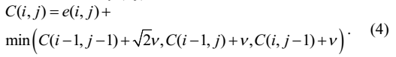

The minimum value of the last row in C indicates the end of minimum cost path. Then, we traced back from the minimum entry on C to find the optimal path as the thorax centerline. To reduce computation time and avoid finding unreasonable thorax centerlines, the search range of the optimal paths was limited in the area from n/3 to 2n/3 columns in a CXR of m × n pixels similar to [25].

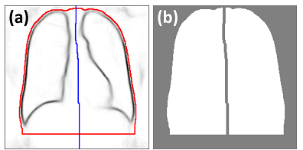

**Fig. 7. Ribcage contour and thorax centerline (a), as well as the corresponding mask (b) for subsequent processing.**

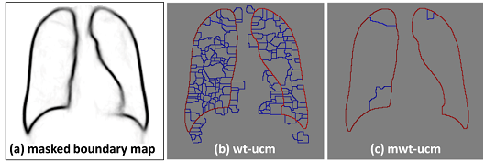

**Fig. 8. WT-UCM (b) and MWT-UCM (c) of a masked boundary map (a). Red/blue color indicates high/low UCM value.**

The produced lung boundary map provided sufficient cues to identify the ribcage. We first determined the top of the ribcage similar to [2]. Considering that the top of the ribcage was more or less circular, we realized the polar transformation of a hemicircle in the boundary map to 128 × 180 pixels for the CXRs of 256 × 256 pixels and then applied dynamic programming to find the optimal path. Fig. 6 shows the computation of the center point and the radius for polar transformation. The radius of the hemicircle was estimated from the intensity profile in the base layer at 1/3 height. We denoted the point with the maximum value on the intensity profile as the center point. Two peaks of the intensity profile on the sides of the center point indicated the rough positions of the right and left ribcages at 1/3 height. The maximum distances (d1 and d2 in Fig. 6(a)) from these two peak locations to the center point were computed as the hemicircle radius. The minimum radius r and the maximum radius R (Fig. 6(b)) were set as 0.5 and 1.4 times the radius for polar transformation, respectively. Fig. 6(c) shows the corresponding polar transformation of the hemicircle region in the boundary map. We regarded the first derivative along the circle radius of the polar transformation image as the energy function for the ribcage top. Similar to finding the thorax centerline, the optimal path was determined by traversing the energy map from the second column to the last column using dynamic programming (Fig. 6(d)).

To determine the left ribcage boundary, we used the end points of the top ribcage boundary as the starting points of the optimal paths. The optimal paths were searched in the rectangular regions. We used the first derivatives along the vertical direction of the boundary map to define the cost functions. For the left/right ribcage boundary, the cost function was regarded as the first forward/backward derivative of the boundary map. The minimum cost path was determined through dynamic programming. We also located the minimum peak on the bottom of vertical projection of boundary map to delimit the area for selection of the lung contours.

We divided each CXR into right, left, and irrelevant areas using the detected ribcage contour and thorax centerline, as shown in Fig. 7(b). To assure that the lung fields are included in the detected ribcage, we enlarged the ribcage using the morphologic dilatation operation as shown in Fig. 7(a). The responses in the irrelevant areas, i.e., gray regions in Fig. 7(b), of the boundary map were masked out and reset to 0.

1. **mwt-ucm: From Boundary Map to Segmentation of Lung Fields**

Once obtained, a boundary map can be utilized for segmentation through several means. However, lung boundary maps predicted by SED are diffused in certain areas. Retrieving segmentation masks from boundary maps is not a straightforward process. The edges produced using ordinary techniques, such as non-maximum suppression from a boundary map, may not be closed. Thus, the edges do not separate the image into regions. Another approach is to integrate a boundary map into the pixel or region probability for labeling in a maximum-a-posteriori framework. However, the trade-off between the region and boundary constraints produces smooth contours, which may not appear in real object boundaries. We opted to create candidate regions or segmentation masks directly from a boundary map by using the over-segmentation or superpixel approaches. WT can be implemented efficiently and effectively; thus, we applied WT to generate over-segmentation from the boundary map. The traditional WT typically produces an excessive number of small irrelevant regions. To reduce the number of such regions, we use MWT to produce over-segmentation regions from the boundary map. We set the pixels of boundary response values less than 0.01 as the markers. Each marker indicates a specific location within the boundary map which is modified by using the minima imposition technique [21]. The modified boundary map only has regional minima in the locations of the markers. Then, the traditional WT is applied to the modified boundary map to obtain segmentation in the belt between the markers. An example of the regions produced from a masked boundary map by WT and MWT is presented in Fig. 8.

We adopted the contour-based hierarchical segmentation method proposed by Arbelaez et al. [19, 20] to generate candidate segments of lung field from the MWT or WT of the masked boundary map. The result of this hierarchical segmentation method is a weighted contour image called UCM, the values of which reflect contour strength and the contrast between neighboring regions [19]. This method generally preserves the global contours of objects while providing hierarchical segments. Such segments are obtained using a greedy graph-based region merging algorithm. Let G(P0, K0, W(K0)) denote an initial graph, where the nodes are the regions P0 generated by WT or MWT, the links are the arcs K0 separating adjacent regions, and the weights W(K0) are a measure of dissimilarity between two adjacent regions which is defined as the average boundary response of SED of their common boundary in K0. The algorithm proceeds by iteratively merging the most similar regions, and produces a tree of regions, where the leaves are the initial elements of P0, the root is the entire image, and the regions are ordered by the inclusion relation [19]. A real-valued image is obtained by weighting each boundary by its scale of disappearance as the UCM, which has the remarkable property of producing a set of closed curves for any threshold. Hierarchical segmentations can be created by setting the UCM thresholds. Fig. 8 presents two examples of UCM with different over-segmentation regions P0.

SED was trained to detect lung boundaries; hence, lung contours are expected to have high UCM values. On the right/left partition of a CXR generated from the detected ribcage and thorax centerline, the contour with the highest UCM value was selected as the right/left lung contour.

1. **Evaluation Metrics**

We used three widely used metrics to evaluate our SEDUCM method quantitatively and compare it with other lung segmentation methods, namely, the Jaccard index (Ω), the Dice similarity coefficient (DSC) [26], and the mean boundary distance (MBD). These metrics were defined and computed as follows.

Let us denote S as the estimated segmentation mask and T as the ground truth mask. Jaccard index was computed as:

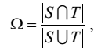

where || is the cardinality of the set, S T  is the intersection of S and T, and S T  is the union of S and T. DSC is the overlap ratio between the ground truth mask T and the estimated segmentation mask S:

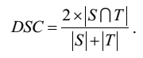

MBD is the average distance between the estimated segmentation boundary S and the ground truth boundary T. Let si and tj be the points on boundaries S and T, respectively. The minimum distance of point si on S to boundary T was computed as:



For MBD computation, the minimum distance for each point on boundary S to boundary T was calculated, and vice versa. These minimum distances were averaged as MBD:

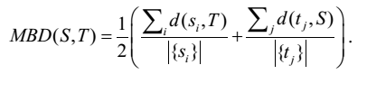

**Chapter-4**

**EXPERIMENTAL RESULTS**

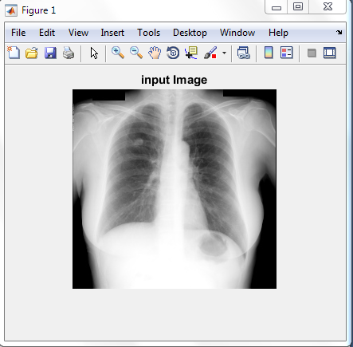

**fig1: input image**

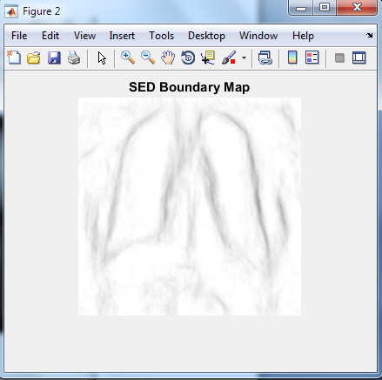

**fig2: sed boundary map of input image**

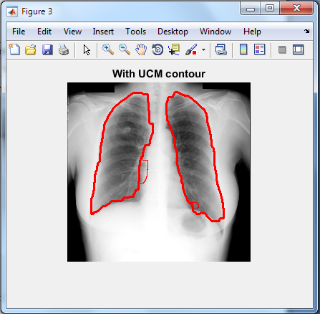

**fig3: ucm contour**

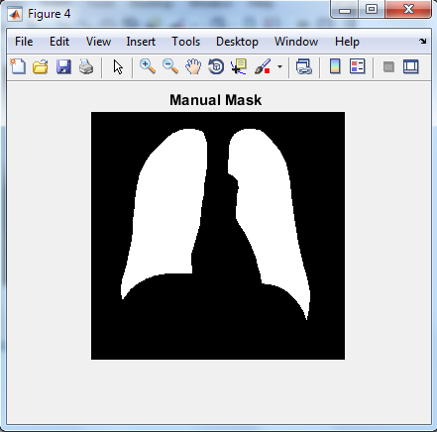

**fig4: manual mask of the image**

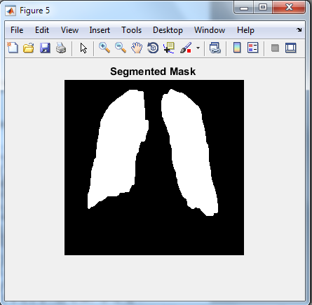

**fig5: final segmentation output image**

**Chapter-5**

**DISCUSSION AND CONCLUSION**

Our method for lung field segmentation employed structured random forests to detect lung boundaries. In principle, modern boundary detectors, such as DeepEdge [17], Oriented Edge Forests [29], and HED [18], can be trained to detect these particular boundaries of lung fields. Among modern boundary detectors, SED exhibits high efficiency, which promotes a fast and practical procedure of lung field segmentation.

The segmentation performance of our method can be further improved. One technique is to combine pixel classification results and the boundary map detected by SED. Another approach is to combine shape models with the boundary map. However, computation time and algorithm complexity increase when these methods are used. A direct approach is to reduce the false boundary responses of SED. In general, a large number of training samples can lead to a relatively good performance of prediction models. We can collect many CXRs with the manual segmentation ground truth to train a SED. Variations in lung field boundaries can be effectively identified using the trained SED.

The segmentation of abnormal lungs is typically difficult. We should develop appropriate rules to address abnormal cases and improve the robustness of SEDUCM. As shown in Fig. 11, our SEDUCM method produces some unreasonable lung contours. The resulting notches by the discontinuity of the detected lung contours can be linked by the smooth curves. Alternatively, the active contour model [30] with a few iterations can be applied to refine the lung contours but with a long computation time.

In summary, we present an effective and efficient lung field segmentation method that can achieve state-of-the-art segmentation accuracy and fulfill the practical requirement of real time. Our method uses a SED to detect lung boundaries. The results demonstrate that effective detection of lung contours using SED and mwt-ucm transform is feasible. Our method can be adopted to simplify approaches for analyzing CXRs.

**REFERENCES**

[1] S. Candemir, S. Jaeger, K. Palaniappan, J. P. Musco, R. K. Singh, X. Zhiyun, A. Karargyris, S. Antani, G. Thoma, and C. J. McDonald, “Lung segmentation in chest radiographs using anatomical atlases with nonrigid registration,” IEEE Trans. Med. Imaging, vol. 33, no. 2, pp. 577-90, Feb, 2014.

[2] B. v. Ginneken, and B. M. t. H. Romeny, “Automatic segmentation of lung fields in chest radiographs,” Med. Phys., vol. 27, no. 10, pp. 2445-2455, 2000.

[3] M. S. Brown, L. S. Wilson, B. D. Doust, R. W. Gill, and C. Sun, “Knowledge-based method for segmentation and analysis of lung boundaries in chest X-ray images,” Computerized Medical Imaging and Graphics, vol. 22, no. 6, pp. 463-477, 1998.

[4] B. v. Ginneken, M. B. Stegmann, and M. Loog, “Segmentation of anatomical structures in chest radiographs using supervised methods: A comparative study on a public database,” Med. Image Anal., vol. 10, pp. 19-40, 2006.

[5] D. Seghers, D. Loeckx, F. Maes, D. Vandermeulen, and P. Suetens, “Minimal shape and intensity cost path segmentation,” IEEE Trans. Med. Imaging, vol. 26, no. 8, pp. 1115-1129, 2007.

[6] Y. Shao, Y. Gao, Y. Guo, Y. Shi, X. Yang, and D. Shen, “Hierarchical lung field segmentation with joint shape and appearance sparse learning,” IEEE Trans. Med. Imaging, vol. 33, no. 9, pp. 1761-1780, 2014.

[7] T. Xu, M. Mandal, R. Long, I. Cheng, and A. Basu, “An edge-region force guided active shape approach for automatic lung field detection in chest radiographs,” Computerized Medical Imaging and Graphics, vol. 36, no. 6, pp. 452-463, 2012.

[8] A. M. R. Schilham, B. van Ginneken, and M. Loog, “A computer-aided diagnosis system for detection of lung nodules in chest radiographs with an evaluation on a public database,” Med. Image Anal., vol. 10, no. 2, pp. 247-258, 2006.

[9] B. van Ginneken, M. B. Stegmann, and M. Loog, “Segmentation of anatomical structures in chest radiographs using supervised methods: a comparative study on a public database,” Med. Image Anal., vol. 10, no. 1, pp. 19-40, 2006.

[10] S. Chen, and K. Suzuki, “Separation of bones from chest radiographs by means of anatomically specific multiple massive-training ANNs combined with total variation minimization smoothing,” IEEE Trans. Med. Imaging, vol. 33, no. 2, pp. 246-257, 2014.

[11] B. Ibragimov, B. Likar, F. Pernus, and T. Vrtovec, “A Game-Theoretic Framework for Landmark-Based Image Segmentation,” IEEE Trans. Med. Imaging, vol. 31, no. 9, pp. 1761-1776, 2012.

[12] Y. Boykov, O. Veksler, and R. Zabih, “Fast approximate energy minimization via graph cuts,” IEEE Trans. Pattern Anal. Mach. Intell., vol. 23, no. 11, pp. 1222-1239, 2001.

[13] J. Canny, “A Computational Approach to Edge Detection,” IEEE Trans. Pattern Anal. Mach. Intell., vol. 8, no. 6, pp. 679-698, 1986.

[14] O. Tsujii, M. T. Freedman, and S. K. Mun, “Lung contour detection in chest radiographs using 1-D convolution neural networks,” Journal of Electronic Imaging, vol. 8, no. 1, pp. 46-53, 1999.

[15] D. R. Martin, C. C. Fowlkes, and J. Malik, “Learning to detect natural image boundaries using local brightness, color, and texture cues,” IEEE Trans. Pattern Anal. Mach. Intell., vol. 26, no. 5, pp. 530-549, 2004.

[16] P. Dollár, and C. L. Zitnick, “Fast Edge Detection Using Structured Forests,” IEEE Trans. Pattern Anal. Mach. Intell., vol. 37, no. 8, pp. 1558-1570, 2015.

[17] G. Bertasius, S. Jianbo, and L. Torresani, “DeepEdge: A multi-scale bifurcated deep network for top-down contour detection,” in 2015 IEEE Conference on Computer Vision and Pattern Recognition (CVPR), 2015, pp. 4380-4389.

[18] S. Xie, and Z. Tu, “Holistically-Nested Edge Detection,” in 2015 IEEE Conference on Computer Vision (ICCV), 2015, pp. 1395-1403.

[19] P. Arbelaez, M. Maire, C. Fowlkes, and J. Malik, “Contour Detection and Hierarchical Image Segmentation,” IEEE Trans. Pattern Anal. Mach. Intell., vol. 33, no. 5, pp. 898-916, 2011.

[20] P. Arbelaez, “Boundary Extraction in Natural Images Using Ultrametric Contour Maps,” in IEEE Conference on Computer Vision and Pattern Recognition Workshop (CVPRW '06) 2006.

[21] P. Soille, Morphological Image Analysis: Principles and Applications, 2nd ed.: Springer Berlin Heidelberg, 2004.

[22] K. He, J. Sun, and X. Tang, “Guided image filtering,” IEEE Trans. Pattern Anal. Mach. Intell., vol. 35, no. 6, pp. 1397-1409, 2013.

[23] L. Breiman, “Random Forests,” Machine Learning, vol. 45, no. 1, pp. 5-32, 2001.

[24] A. Criminisi, and J. Shotton, Decision Forests for Computer Vision and Medical Image Analysis: Springer, 2013.

**APPENDIX-I**

**MATLAB**

**1 INTRODUCTION**

MATLAB is a tip pinnacle tongue for precise making ready .It organizes figuring belief and in addition programming in a easy to make use of condition. Tangle lab stays for grid observe focus. It changed into shaped at the start to give direct get right of entry to to prepare programming made by way of LINPACK and EISPACK meanders. MATLAB is as desires be based on foundation of cutting part matrix programming wherein fundamental segment is arrange which require no longer utilize pre dimensioning Normal jobs of MATLAB

1. Math and estimation

2. Algorithm change

3. Data getting

4. Data examination, examination and acknowledgment

5. Scientific and building designs

6. The guideline features of MATLAB

1. Propel figuring for unrivaled numerical include, particularly the Field element polynomial math

2. An expansive get-together of predefined predictable purposes of control and the ability to portray one's own specific limits.

3. Two-and three dimensional layouts for plotting and indicating data

4. An aggregate online help structure

5. Skilled, component or vector dealt with odd state programming tongue for particular applications.

6. Tool compartments accessible for managing in the midst of cutting edge issues in a few utilize districts.

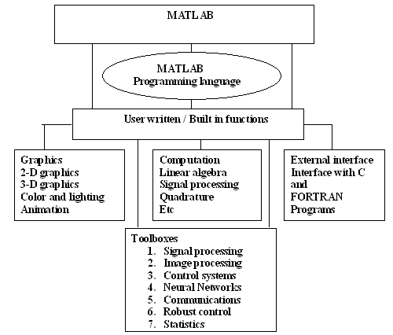

Fig. 1 Applications of MATLAB

**5.2**. **The MATLAB System:**

The MATLAB substance incorporates five fundamental parts:

**5.2.1 Development Environment**

This is the way of contraptions and workplaces that assistance you work MATLAB cutoff centers and realities. A fundamental scope of those devices is graphical UIs. It solidifies the MATLAB artistic creations region and Command Window, a value history, a bit of composing supervisor and debugger, and tries for diagram help, the workspace, records, and the pastime way.

**5.2.2 The MATLAB Mathematical Function Library:**

This is an enormous party of computational counts running from clear limits, like entire, sine, cosine, and complex number juggling, to more present day limits like component rotate, component Eigen regards, Bessel cutoff focuses, And practical Fourier changes.

**5.2.3 The MATLAB Language**

This is a shocking kingdom system/group dialect amidst oversee course illuminations, limits, records structures, enter/yield, and investigate composed programming features. It licenses both "programming inside the little" to hurriedly make brisk and tarnished unimportant games, and "programming inside the liberal" to make sizeable and confused utility projects.

**5.2.4 Graphics**

MATLAB has broad sketches situations for showing vectors and factors as diagrams, and aside from clarifying and printing these charts. It wires standard nation confines amidst regards to two-dimensional and three-dimensional information delineation, video orchestrating, improvement, and creation depictions. It likewise joins low-degree compels that empower you to exceptionally well change the vicinity of systems and paying little mind to make end graphical UIs to your MATLAB bundles.

**5.2.5 The MATLAB Application Program Interface (API)**

This is a lib. That enables you to frame C and Fortran prog's that interface amidst MATLAB. It solidifies work environments for calling designs from MATLAB (dynamic partner), calling MATLAB as a computational motor, and for breaking down and making MAT-documents.

**5. 3 Starting MATLAB**

On Windows stages, begin MATLAB by twofold tapping the MATLAB exchange way picture on your Windows work zone. On UNIX stages, begin MATLAB by impacting mat lab at the working portion to actuate. You can change MATLAB startup. For instance, you can change the registry in which MATLAB begins or thusly execute MATLAB affirmations in a substance record named new affiliations.

**5.3.1 MATLAB Desktop**

When you start MATLAB, the MATLAB work area shows up, containing contraptions (graphical UIs) for administering documents, segments, and applications related in the midst of MATLAB. The running with plot demonstrates the default work zone. You can change the arrangement of contraptions and reports to suit your necessities. For more information about the work district mechanical social events.

**5.3.2 .MATLAB Working Environment MATLAB Desktop:**

MATLAB Desktop is the vital Mat lab utility window. The work zone comprises of 5 sub home windows: the call for window, the workspace application, the present registry window, the summon records window, and no short of what one parent home windows, that are demonstrated definitely when the benefactor surely understood demonstrates a the distance sensible.

The charge window is the situated inside the purchaser writes MATLAB sales and verbalizations on the induce (>>) and in which the yield of these requesting is appeared. MATLAB delineates the workspace on the grounds that the procedure of fragments that the client makes in a piece session. The workspace program exhibits these segments and a few records about them. Twofold tapping on a variable inside the workspace programming dispatches the Array Editor, which likely used to get measurements and pay events exchange certain properties of the variable.

The blessing Directory tab over the workspace tab shows the substance of the current registry, whose way is respected in the blessing report window. For example, inside the windows working substance the way can likewise accord to the running with: C:MATLABWork, demonstrating that registry "work" is a subdirectory of the essential record "MATLAB", WHICH IS INSTALLED IN DRIVE C. Tapping at the dash inside the present stock window demonstrates a snappy assessment of starting late connected strategies. Tapping at the seize to the contrary aspect of the window connects with the customer to substitute the common once-over.

The Command History Window incorporates a report of the summons a customer has entered inside the charge window, alongside each present and past MATLAB periods. In support entered MATLAB charges possibly picked and re-executed from the summon History window by means of legitimate tapping on a demand or course of action of solicitations. This development dispatches a menu from which to pick diverse choices despite executing the expenses. This is an utilization to pick stand-out choices notwithstanding executing the expenses. This is helpful viewpoint while attempting exceptional issues in the midst of various costs in a work session.

**5.3.3 Using the MATLAB Editor to make M-Files**

The MATLAB manager is each an expression processor novel for making M-data and a graphical MATLAB debugger. The book pioneer can appear in a window and not utilizing an other character or it likely a sub window in the work zone. M-records are shown by means of the exchange .M, as in pixelup.M. The MATLAB stream chief window has exact draw down menus for assignments, as a case, sparing, seeing, and taking a gander at audits. Since it plays out some unmistakable exams additionally utilizes shading to isolate among different bits of code, this expression processor is clutched in light of the fact that the apparatus of want for trim and propelling M-limits. To open the movement real, type exchange on the prompt opens the M-report filename's in a digital book executive window, made creating. As observed some time starting past due, the record must be inside the stream registry, or in an abstract inside the side interest way.

**5.3.4 Getting Help**

The principal procedure to bargain in the midst of get help on line is to utilize the MATLAB help program, opened as a substitute window both by method for tapping at the question mark picture (?) at the artworks domain toolbar, or with the guide of impacting help to application at the impact in the demand window. The help Browser is a web programming made into the MATLAB work an area that introductions a Hypertext Markup Language (HTML) records. The Help Browser joins two sheets, the help set up sheet, used to find data, and the show sheet, used to see the realities.

Plain as day tabs other pilot sheet are utilized to play out an intrigue. For instance, help on a chose purpose of containment is gotten by choosing the interest tab, choosing Function Name in light of the fact that the Search Type, and after that composition inside the cutoff name inside the Search for teach. It is superb exercise to open the Help Browser nearer to the start of a MATLAB session to have help fast convenient in the midst of code advancement or distinctive MATLAB task.

Another method to good buy inside the midst of get for a specific factor of confinement is by creating document taken after with the aid of the maximum call at the demand incites. For example, growing document design exhibits documentation for the cutoff points referred to as set up inside the display sheet of the Help Browser. This summons opens the program on the off threat that it is not at once open.

**5.3.5 Saving and Retrieving a Work Session**

There are a few ways to deal with deal amidst extra and stack an entire work session or picked workspace factors in MATLAB. The scarcest complex is according to the running with. To spare the whole workspace, in a general sense right-tap on any sensible space in the workspace Browser window and select Save Workspace As from the menu that shows up. This opens a registry window that licenses naming the record and picking any facilitator in the structure in which to spare it. By then basically snap Save.

To spare a picked variable from the workspace, select the variable in the midst of a left snap and a compact navigate later right-tap on the included zone. By then select Save Selection As from the menu that shows up. This again opens a window from which a facilitator maybe spared the variable.

To pick different segments, utilize move snap or control click in the standard way, and after that utilization the framework basically depicted for a solitary variable. All records are spared in the twofold exactness, parallel outline amidst the amplification '. Tangle'. These spared reports normally are recommended as MAT-records. For instance, a session named, says mywork_2003-02-10, and would show up as the MAT-record mywork_2003_02_10.mat when spared. Additionally, a spared video called last video will show up when spared as final_video.mat.

**5.3.6 Graph Components**

MATLAB shows diagrams in an exceptional window known as a figure. To make a graph, you need to portray an arrange structure. In this manner each chart is put inside tomahawks, which are contained by the figure. The true blue visual depiction of the data is skilled in the midst of plans objects like lines and surfaces. These articles are drawn inside the arrangement with substance delineated by the tomahawks, which MATLAB conventionally makes especially to oblige the level of the data. The real data is secured as properties of the plans objects.

5.3.7 Plotting Tools

Plotting devices are related with figures and make a zone for making Graphs. These instruments draw in you to do the running with:

• Select from a wide assortment of diagram sorts

• Change the kind of graph that tends to a variable

• See and set the properties of portrayals objects

• Annotate plots amidst substance, shocks, and so on.

• Create and manage subplots in the figure

• Drag and drop data into plot

Exhibit the plotting instruments from the View menu or by tapping the plotting mechanical get together's picture in the figure toolbar, as appeared in the running with picture.

5.3.8 Editor/Debugger

Use the Editor/Debugger to make and research M-records, which are programs you write to run MATLAB limits. The Editor/Debugger gives a graphical UI to word preparing, and for M-record taking a gander at. To make or adjust a M-report use File > New or File > Open, or use the change work.

**5.3.9 Feature Development**

Feature headway happens as takes after:

• A MySQL feature is demonstrated in a Work log area.

• The Work log entry encounters detail, layout, designing and QA reviews (yet not by any stretch of the imagination in a strict progression).

• The MySQL feature is executed in a component tree.

• Feature trees are produced using and kept in a condition of congruity in the midst of the MySQL basic change tree, which is called TRUNK

• When a part has been executed, it encounters a code study.

• When the code overview is done, the part tree is offered over to QA (quality certification).

• QA tests the part, the implementer fixes bugs, and QA over the long haul "shuts down" the component.

• Once the segment is shut down, it is joined into TRUNK. Thusly, TRUNK will total features and bug settles after some time. Wide backslide testing is performed on TRUNK continually, keeping TRUNK close Release Candidate (RC) quality reliably.

**5.4 Feature Testing**

New capabilities in MySQL are made and attempted in discrete phase timber earlier than they're pushed to TRUNK. Quality goals for brand new functions are the going with:

• Complete helpful and nonfunctional take a look at extent of changed and new price

• No backslides

• At least extra than eighty% code scope QA association starts offevolved while the necessities and particulars of the section are settled with the aid of the headway collecting.

QA overviews available files and gives contribution on the association, accommodation, testability, et cetera. An alternate takes after in the midst of the designer and modifications are fabricated from course to make sure that the element probably attempted.

Once the particulars and necessities are suitable, QA affects the test to organize which reviews all circumstances which are to be attempted. This fuses free tests, becoming a member of exams, nonfunctional tests, et cetera. The take a look at configuration is kept an eye on with the aid of designers and partner QA buddies. While the planners are forming the component code, QA engineers start tackling the mechanized tests, test status quo enhancements, et cetera. The final spherical of trying out starts after the aspect has passed code studies. This degree can last anyplace among numerous days to months, structured upon the multifaceted concept of the factor, satisfactory of the code, variety of bugs found, et cetera. Features get close down when the going with situations are met:

• No known bugs in the new part – This is inside and out affirmed and even minor bugs are not permitted. We accept that bugs are most simple to settle when the code is new, and thusly this can enable us to pass on highlights that are of high bore.

• No known falls away from the faith – A part gets made on a tree which gets endeavored as regularly as conceivable through a consistent joining testing contraption. Any descends into sin are seen and settled before signoff.

• Adequate code scope numbers – A code scope report is made for the changed lines of code and the base expected degree is 80%. Most highlights have a degree of over 90%. Any revealed lines of code are broke down and, wherever conceivable, new tests are added to develop code scope.

• Every single new test are added to the mechanized apostatize suite.

The MySQL web page depicts MySQL as the "world's maximum widespread Open Source database." Its regularity isn't any weakness maintained via the manner that on the off chance that you require MySQL for non-enterprise make use of, you could download a reproduction loose from the internet site web page. MySQL is about dependably packaged amidst the PHP internet scripting vernacular, and the 2 matters are as regularly as attainable regarded stated collectively. Most Linux spreads run with MySQL and PHP as popular and MySQL has been ported for use to a large collection of stages. Because of its packaging amidst PHP, MySQL is routinely utilized as a database lower back quit to a web server.

DBMS MySQL is what's referred to as a Database Management element (DBMS). The company substance picks how the statistics is secured, masterminded and recuperated, and also controlling client get entry to to it. Each time a purchaser recoups records, eradicates facts, or contains more records, the DBMS deals with the request. The patron can't get to the records facts mainly, he can sincerely speak within the midst of the DBMS.

The company substance is an impediment that controls get entry to to the shrouded records., and cannot go especially to the database itself. MySQL Databases MySQL can manipulate multiple databases without delay. For instance, while you gift MySQL, the detail makes the element database which is called mysql. This database includes most of the 2 Database Design Manual: using MySQL for Windows facts required to describe any of the sports that MySQL desires to carry out. It shops purposes of enthusiasm of diverse databases, clients and every and every different file that the element makes use of to shop facts. It itself is an aggregation of records used for a specific reason.

This makes My SQL self-delineating, in that the tables that it shops are used to depict particular tables that it stores whilst you are affecting your personal specific plans of facts to make those in some other database. In this e-book we are able to use the mysql database to examine particular shape limits, however by a ways maximum of the alternative information that we make might be secured in a database called mysqlfast. MySQL can without a number of a widen manipulate multiple database, so as to hold your tables being combined up for thing facts, it's far first-rate to drag back them by using the use of particular databases.

**5.5 SQ Lite**

This SQ Lite instructional exercise demonstrates to all of you that you need to know to start using SQ Lite sufficiently. You will learn SQ Lite through wide hands-on sharpens. SQ Lite Tutorial If you have been working in the midst of other social database organization elements e.g., My SQL, Posture SQL, Oracle, Microsoft SQL Server, et cetera., and you got some answers concerning SQ Lite. In addition, you are intrigued to get some answers concerning it. In case your sidekicks recommended you use SQ Lite database as opposed to essential archives to regulate composed data in your applications. You have to start in the midst of SQ Lite rapidly to check whether you can utilize it for your applications. In case you are basically starting learning SQL and need to use SQ Lite as the database system. In case you are one of the overall public portrayed over, this SQ Lite instructional exercise is for YOU. SQ Lite is an open source, zero-game plan, autonomous, stay single, trade social database engine expected to be embedded into an application.

**Getting Help:**

The major way to get help online is to use the MATLAB assist browser, opened as a separate window each thru clicking at the query mark symbol (?) at the computing device toolbar, or via typing help browser at the activate inside the command window. The assist Browser is an internet browser protected into the MATLAB computer that displays a Hypertext Markup Language (HTML) files. The Help Browser includes two panes, the help navigator pane, used to discover statistics, and the display panel used to view the facts. Self-explanatory tabs apart from navigator pane are used to carry out an are looking for.

**Appendix B**

# INTRODUCTION TO DIGITAL IMAGE PROCESSING

# 6.1 What is DIP?

A photo can be described as a -dimensional characteristic f(x, y), in which x & y are spatial coordinates, & the amplitude of f at any pair of coordinates (x, y) is known as the depth or grey stage of the photograph at that point. When x, y & the amplitude values of f are all finite discrete portions, we name the image a virtual image. The discipline of DIP refers to processing digital photo through a virtual laptop. Digital photograph consists of a finite range of factors, every of which has a selected location & charge. The elements are known as pixels.

Vision is the most advanced of our sensor, so it isn't unexpected that photoplay the single maximum essential function in human belief. However, an assessment to people, who're confined to the visible band of the EM spectrum imaging machines cowl nearly the whole EM spectrum, beginning from gamma to radio waves. They can characteristic additionally on pix generated by way of resources that humans aren't familiar with associating with the picture.

There is not any giant agreement amongst authors regarding in which picture processing stops & different related areas which include photo evaluation& pc imaginative and prescient start. Sometimes a difference is made with the resource of defining picture processing as a subject in which every the input & output at a process are photos. This is limiting & relatively artificial boundary. The vicinity of photograph evaluation (picture know-how) is in between photo processing & computer imaginative and prescient.

There aren't any uncomplicated obstacles within the continuum from picture processing at one end to complete imaginative and prescient at the alternative. However, one useful paradigm is to undergo in thoughts three sorts of automatic strategies on this continuum: low-, mid-, & excessive-degree approaches. The low-degree approach involves primitive operations which incorporate image processing to reduce noise, evaluation enhancement & picture sharpening. A low- diploma technique is characterized by the resource of the reality that both its inputs & outputs are photographs. Mid-degree procedure on snapshots includes duties together with segmentation, description of that object to lessen them to a shape suitable for pc processing & type of character gadgets. A mid-diploma method is characterized thru the fact that its inputs commonly are photographs however its outputs are attributes extracted from the one's photos. Finally higher- stage processing includes “Making enjoy” of an ensemble of recognized devices, as in image evaluation & at the along manner stop of the continuum acting the cognitive competencies typically related to human imaginative and prescient.

Digital picture processing, as already described is used efficiently in a large range of areas of wonderful social & monetary rate.

**6.2 What is a photo?**

An image is represented as a two dimensional characteristic f(x, y) where x and y are spatial co-ordinates and the amplitude of ‘f’ at any pair of coordinates (x, y) is called the depth of the picture at that point.

**Grayscale photograph:**

A grayscale photograph is a feature I (xylem) of the two spatial coordinates of the picture plane.

I(x, y) is the depth of the photo at the factor (x, y) at the photographing plane.

I (xylem) takes non-poor values expect the picture is bounded thru a rectangle [0, a] [0, b]I: [0, a]  [0, b]  [0, facts)

**Color photo:**

It may be represented through 3 capabilities, R (xylem) for crimson, G (xylem) for green and B (xylem) for blue.

A picture can be continuous with respect to the x and y coordinates and also in amplitude. Converting such an photo to digital shape calls for that the coordinates in addition to the amplitude to be digitized. Digitizing the coordinate’s values is referred to as sampling. Digitizing the amplitude values is known as quantization.

**6.3 Coordinate conventions:**

The end result of sampling and quantization is a matrix of actual numbers. We use primary procedures to symbolize virtual snap shots. Assume that an photograph f(x, y) is sampled in order that the resulting image has M rows and N columns. We say that the image is of period M X N. The values of the coordinates (xylem) are discrete portions. For notational readability and convenience, we use integer values for those discrete coordinates. In many picture processing books, the image beginning is defined to be at (xylem)=(0,0).

The subsequent coordinate values along the number one row of the photograph are (xylem)=(zero,1).It is essential to keep in mind that the notation (0,1) is used to suggest the second sample along the primary row. It does not suggest that these are the real values of physical coordinates at the same time as the photograph become sampled. Following figure shows the coordinate convention. Note that x stages from zero to M-1 cease y from 0 to N-1 in integer increments.

The coordinate convention used within the toolbox to signify arrays is not just like the previous paragraph in minor tactics. First, in region of the usage of (xylem) the toolbox uses the notation (race) to indicate rows and columns. Note, however, that the order of coordinates is much like the order discussed inside the preceding paragraph, in the sense that the first detail of a coordinate topples, (alb), refers to a row and the second to a column.

The specific difference is that the beginning of the coordinate gadget is at (r, c) = (1, 1); for that reason, r degrees from 1 to M and c from 1 to N in integer increments. IPT documentation refers to the coordinates. Less often the toolbox additionally employs some other coordinate convention known as spatial coordinates which uses x to refer to columns and y to refers to rows. This is the opportunity of our use of variables x and y.

**6.4 Image as Matrices:**

The previous dialogue leads to the subsequent illustration for a digitized photograph feature:

f (0, 0) f (0, 1) ……….. f (0, N-1)

f (1, 0) f (1, 1) ………… f (1, N-1)

f (xylem) = . . . . . . f (M-1, 0) f (M-1, 1) ………… f (M-1, N-1)The right side of this equation is a digital photograph with the aid of definition. Each element of this array is known as an image detail, photo element, pixel or pel. The terms photo and pixel are used throughout the rest of our discussions to indicate a digital photo and its elements. A virtual photo can be represented evidently as a MATLAB matrix:

f (1, 1) f (1, 2) ……. f (1, N) f (2, 1) f (2, 2) …….. f (2, N) . . . f = . . . f (M, 1) f (M, 2) …….f (M, N)Where f (1, 1) = f (zero, 0) (be conscious the use of a monoscope font to indicate MATLAB portions). Clearly the 2 representations are identical, except for the shift in beginning vicinity. The notation f (p, q) denotes the detail positioned in row p and the column q. For example f (6, 2) is the element in the sixth row and second column of the matrix f. Typically we use the letters M and N respectively to suggest the range of rows and columns in a matrix. A 1xN matrix is called a row vector at the same time as an Mx1 matrix is known as a column vector. A 1x1 matrix is a scalar.

Matrices in MATLAB are stored in variables with names which encompass A, a RGB, real array and so on. Variables ought to start with a letter and include best letters, numerals, and underscores. As stated within the preceding paragraph, all MATLAB quantities are written using monoscope characters. We use conventional Roman, italic notation such as f(x, y), for mathematical expressions.

**6.5. Reading Images:**

Images are examine into the MATLAB surroundings the use of characteristic imread whose syntax is

Imread (‘filename’)

**Format name Description recognized extension** TIFF Tagged Image File Format .tif, .tiff JPEG Joint Photograph Experts Group .jpg, .jpeg GIF Graphics Interchange Format .gif BMP Windows Bitmap .bmp PNG Portable Network Graphics .png XWD X Window Dump .xwd

Here filename is a spring containing the whole of the photograph file(including any relevant extension).For example the command line

>> f = imread (‘eight. Jpg’);

Reads the JPEG (above table) photograph chestxray into photo array f.

Note the usage of unmarried charges (‘) to delimit the string filename.

The semicolon on the cease of a command line is utilized by MATLAB for suppressing output. If a semicolon isn't always included. MATLAB presentations the consequences of the operation(s) laid out in that line. The prompt image (>>) designates the start of a command line, as it appears in the MATLAB command window.

When as within the previous command line no course is blanketed in filename, imread reads the record from the modern listing and if that fails it attempts to discover the report in the MATLAB search path. The most effective way to study an picture from a certain directory is to include a complete or relative path to that listing in filename.

For example,

>> f = imread (‘D: myimageschestxray.Jpg’);

reads the image from a folder known as my pictures at the D: force, while

>> f = imread(‘ . Myimageschestxray .Jpg’);

Reads the picture from the my photos subdirectory of the present day of the cutting-edge running listing.

The modern listing window at the MATLAB laptop toolbar shows MATLAB’s contemporary running directory and provides an easy, manual manner to change it. Above table lists a number of the maximum of the famous image/photographs formats supported via imread and imwrite. Function size offers the row and column dimensions of an image:

>> Length (f) ans = 1024 * 1024

This feature is mainly beneficial in programming while used in the following form to determine automatically the dimensions of an picture:

>>[M,N]=size(f); This syntax returns the quantity of rows(M) and columns(N) within the photograph.

The complete feature presentations extra records approximately an array.

For instance ,the statement>> whos fgives Name size Bytes Class F 1024*1024 1048576 unit8 arrayGrand total is 1048576 elements using 1048576 bytesThe unit8 entry shown refers to one of several MATLAB data classes. A semicolon at the end of a whose line has no effect ,so normally one is not used.**6.6 Displaying Images:**Images are displayed on the MATLAB desktop using function imshow, which has the basic syntax: imshow(f,g)Where f is an image array, and g is the number of intensity levels used to display it. If g is omitted ,it defaults to 256 levels .using the syntax Imshow (f, {low high})Displays as black all values less than or equal to low and as white all values greater than or equal to high. The values in between are displayed as intermediate intensity values using the default number of levels .Finally the syntax Imshow(f,[ ])Sets variable low to the minimum cost of array f and excessive to its maximum fee. This shape of imshow is useful for showing snap shots which have a low dynamic range or that have splendid and terrible values.

Function pixval is used regularly to show the depth values of individual pixels interactively. This function suggests a cursor overlaid on an image. As the cursor is moved over the photograph with the mouse the coordinates of the cursor role and the corresponding intensity values are validated on a show that looks under the discern window .When working with color pix, the coordinates in addition to the red, green and blue components are displayed. If the left button on the mouse is clicked after which held pressed, pixval shows the Euclidean distance a number of the preliminary and contemporary cursor locations.

The syntax form of hobby here is Pixval which shows the cursor at the final photograph displayed. Clicking the X button at the cursor window turns it off.

The following statements look at from disk an photograph called rose_512.Tif extract easy statistics approximately the picture and display it the usage of imshow

:>>f=imread(‘rose_512.tif’);>>whos f

**Name Size Bytes Class** F 512*512 262144 unit8 arrayGrand total is 262144 elements using 262144 bytes>>imshow(f)A semicolon on the quit of an imshow line has no impact, so commonly one is not used. If some other photograph,g, is displayed using imshow, MATLAB replaces the photo within the screen with the new photo. To preserve the primary photograph and output a 2nd image, we use feature figure as follows:

>>discern ,imshow(g)

Using the declaration >>imshow(f),parent ,imshow(g) presentations each pictures.

Note that a couple of command may be written on a line,so long as unique instructions are nicely delimited by commas or semicolons. As cited in advance, a semicolon is used each time it's far preferred to suppress screen outputs from a command line.

Suppose that we have just read an photo h and locate that the usage of imshow produces the photo. It is apparent that this photograph has a low dynamic variety, which can be remedied for show purposes via the usage of the declaration. >>imshow(h,[ ])